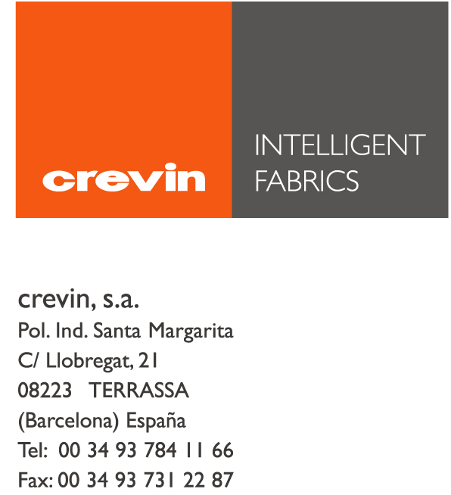

ORIENT OCCIDENT

SUBJECT: OEKO-TEX CERTIFICATION

Terrassa, March 6th 2017

Dear Sir,

We come back to your request on Oeko-Tex certificate for the articles purchased from us.

We regret to inform you we do not have this certification for any of the articles involved at present. Nevertheless is important to remark that all our yarn and product suppliers are Oekotex Certified.

However, we would like to point out that our Environmental Management System is certificated in accordance with the standard UNE-EN-ISO 14001:2004; this proves that our concern on environmental issues is firm, although we do not foresee to achieve any product certificate in short term.

In addition, we confirm Crevin does not use during the manufacturing process any of those substances which are prohibited or regulated by law or chemicals which are known to be harmful to health (Substances of Very High Concern according to new regulation REACH).

In case we can be of any further help, please let us know.

Best regards

Maria José Marín
Quality and Environment Department
CREVIN S.A.

